Game Design Document

Fill up the following document

1. Write the title of your project.

Boss hunt

1. What is the goal of the game?

The minion will be running and they should find there their boss

1. Write a brief story of your game.

So obsticles will be coming in the middle like dru ,breat,bubble gum

Etc.,and bananas will be coming should be collected by minions

1. Which are the playing characters of this game?

* Playing characters are the ones who respond to the user based on the input from the user.
* Cars, monkeys, dinos, wizards, etc., are the playing characters in the game.

|  |  |  |
| --- | --- | --- |
| Number | Character Name | What can this character do? |
| 1 | minions | PC |
| 2 |  |  |
| 3 |  |  |
| 4 |  |  |
| 5 |  |  |
| 6 |  |  |
| 7 |  |  |
| 8 |  |  |

1. Which are the Non-Playing Characters of this game?

* Non-Playing characters are the ones that don't have an action or behavior when the user interacts with the game.
* Hurdles, stones, bananas, coins, etc., are non-playing characters in the game.

|  |  |  |
| --- | --- | --- |
| Number | Character Name | What can this character do? |
| 1 | banana |  |
| 2 | breat |  |
| 3 | dru |  |
| 4 | gru |  |
| 5 | bubble |  |
| 6 |  |  |
| 7 |  |  |
| 8 |  |  |

Draw your imagination of this game. What does this game look like?

* Draw the game either on your computer or on paper.
* Add images of the game scenes to show each of the playing and non-playing characters at least once.

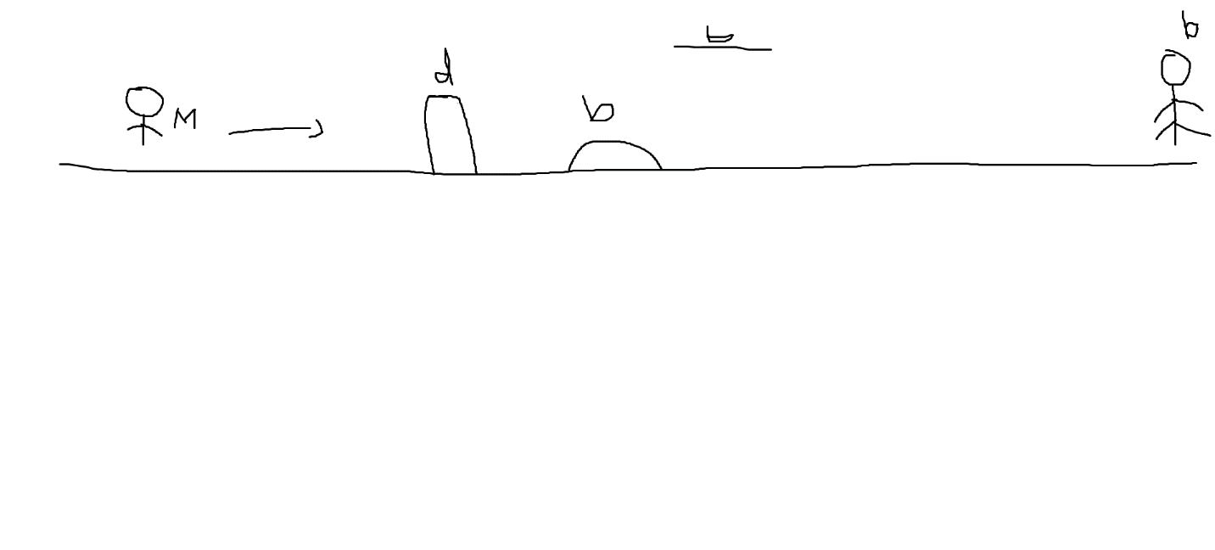

How do you plan to make your game engaging?

Game speed wii be increased when the score increases